ECE 124- Lab2 Report

VHDL CODE

Code for Logic processor

library ieee;

use ieee.std_logic_1164.all;

use ieee.numeric_std.all;

entity LogicProcessor is port (

INPUT_A : in std_logic_vector(3 downto 0);

INPUT_B : in std_logic_vector(7 downto 4);

OPTION: in std_logic_vector(3 downto 0);

OUTPUT: OUT std_logic_vector(7 downto 0)

);

end LogicProcessor;

architecture Behavioral of LogicProcessor is

begin

with OPTION(3 downto 0) select

-- based on the button clicked, determine the logic used for each digit

OUTPUT <= "0000" & INPUT_A AND INPUT_B when "1110",

"0000" & INPUT_A OR INPUT_B when "1101",

"0000" & INPUT_A XOR INPUT_B when "1011",

"11111111" when others;

-- we handle unexpected input in the MUX

end architecture Behavioral;

Code for Mux-led signals

library ieee;

use ieee.std_logic_1164.all;

use ieee.numeric_std.all;

entity MUX_LED is port (

INPUT_A : in std_logic_vector(7 downto 0);

INPUT_B : in std_logic_vector(7 downto 0);

CONTROL: in std_logic_vector(3 downto 0);

OUTPUT: OUT std_logic_vector(7 downto 0)

);

end MUX_LED;

architecture Behavioral of MUX_LED is

begin

--if nothing is pressed, then output 00000000

--if pb3 is pressed, output addition result on LED

--if anything but pb3 is pressed, output logic on LED

--if received unexpected result, light up all LEDs

with CONTROL (3 downto 0) select

OUTPUT <= "00000000" when "1111",

INPUT_A when "0111",

INPUT_B when "1011",

INPUT_B when "1101",

INPUT_B when "1110",

"11111111" when others;

end architecture Behavioral;

Code for the Logic Adder

library ieee;

use ieee.std_logic_1164.all;

use ieee.numeric_std.all;

entity LogicAdder is port (

INPUT_A : in std_logic_vector(3 downto 0);

INPUT_B : in std_logic_vector(7 downto 4);

OUTPUT: OUT std_logic_vector(7 downto 0)

);

end LogicAdder;

architecture Behavioral of LogicAdder is

begin

-- First convert logic to integer so we can perform addition on INPUT_A and INPUT_B,

-- then convert it back into the logic, so we can feed it to both led and 7seg

OUTPUT(7 downto 0) <= std_logic_vector(unsigned("0000" & INPUT_B) + unsigned("0000" & INPUT_A));

end architecture Behavioral;

Code for the edited main VHDL file

library ieee;

use ieee.std_logic_1164.all;

use ieee.numeric_std.all;

entity LogicalStep_Lab2_top is port (

clkin_50 : in std_logic;

pb : in std_logic_vector(3 downto 0);

sw : in std_logic_vector(7 downto 0); -- The switch inputs

leds : out std_logic_vector(7 downto 0); -- for displaying the switch content

seg7_data : out std_logic_vector(6 downto 0); -- 7-bit outputs to a 7-segment

seg7_char1 : out std_logic; -- seg7 digit1 selector

seg7_char2 : out std_logic -- seg7 digit2 selector

);

end LogicalStep_Lab2_top;

architecture SimpleCircuit of LogicalStep_Lab2_top is

--

-- Components Used ---

-------------------------------------------------------------------

component SevenSegment port (

hex : in std_logic_vector(3 downto 0); -- The 4 bit data to be displayed

sevenseg : out std_logic_vector(6 downto 0) -- 7-bit outputs to a 7-segment

);

end component;

component segment7_mux port (

clk : in std_logic :='0';

DIN2 : in std_logic_vector(6 downto 0);

DIN1 : in std_logic_vector(6 downto 0);

DOUT : out std_logic_vector(6 downto 0);

DIG2 : out std_logic;

DIG1 : out std_logic

);

end component;

component LogicProcessor port (

INPUT_A : in std_logic_vector(3 downto 0);

INPUT_B : in std_logic_vector(7 downto 4);

OPTION : in std_logic_vector(3 downto 0);

OUTPUT : OUT std_logic_vector(7 downto 0)

);

end component;

component LogicAdder port (

INPUT_A : in std_logic_vector(3 downto 0);

INPUT_B : in std_logic_vector(7 downto 4);

OUTPUT : OUT std_logic_vector(7 downto 0)

);

end component;

component MUX port (

INPUT_A : in std_logic_vector(7 downto 0);

INPUT_B : in std_logic_vector(7 downto 0);

CONTROL : in std_logic_vector(3 downto 0);

OUTPUT : OUT std_logic_vector(7 downto 0)

);

end component;

component MUX_LED port (

INPUT_A : in std_logic_vector(7 downto 0);

INPUT_B : in std_logic_vector(7 downto 0);

CONTROL : in std_logic_vector(3 downto 0);

OUTPUT : OUT std_logic_vector(7 downto 0)

);

end component;

-- Create any signals, or temporary variables to be used

--

-- std_logic_vector is a signal which can be used for logic operations such as OR, AND, NOT, XOR

--

signal seg7_A : std_logic_vector(6 downto 0);

signal seg7_B : std_logic_vector(6 downto 0);

signal hex_A : std_logic_vector(3 downto 0);

signal hex_B : std_logic_vector(7 downto 4);

--stores result for adder

signal adder : std_logic_vector(7 downto 0);

--stores result for logic

signal logic : std_logic_vector(7 downto 0);

--stores result for the chosen seg7

signal seg7 : std_logic_vector(7 downto 0);

--NOTE, we don't store result for LED since we can directly implement it on the output

-- Here the circuit begins

begin

--seperate sw into two 4 bit logic for convinient usage in the future

hex_A <= sw(3 downto 0);

hex_B <= sw(7 downto 4);

--compute logic output based on sw and pb

LOGIC_OUTPUT: LogicProcessor port map(hex_A, hex_B, pb, logic);

--compute adder result based on sw and pb

ADDER_OUTPUT: LogicAdder port map(hex_A, hex_B, adder);

--choose the right input for LED

LED_INPUT: MUX_LED port map(adder, logic, pb, leds);

--choose the right input for 7Seg

SEG7_INPUT: MUX port map(sw, adder, pb, seg7);

--processing 7Seg and output it to seg7_data, seg7_char2, seg7_char1

INST1: SevenSegment port map(Seg7(3 downto 0), seg7_A);

INST2: SevenSegment port map(Seg7(7 downto 4), seg7_B);

INST3: segment7_mux port map(clkin_50, seg7_A, seg7_B, seg7_data, seg7_char2, seg7_char1);

end SimpleCircuit;

Simulation of the AND function

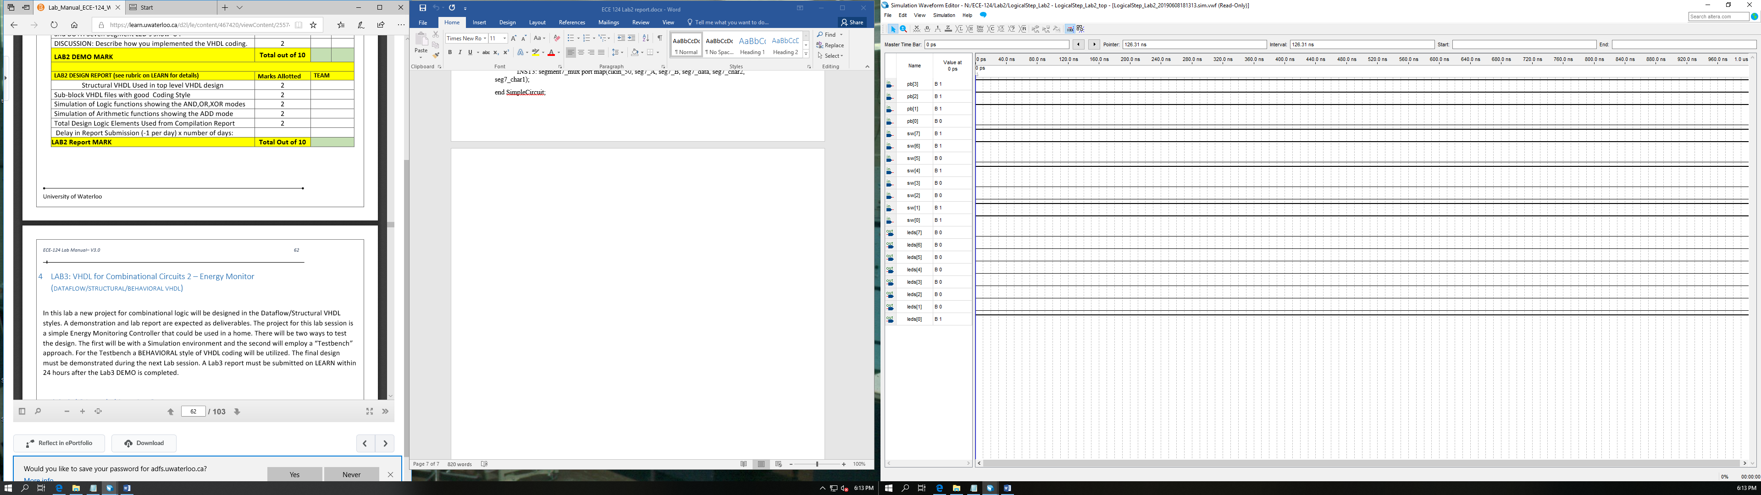

Simulation of the OR function

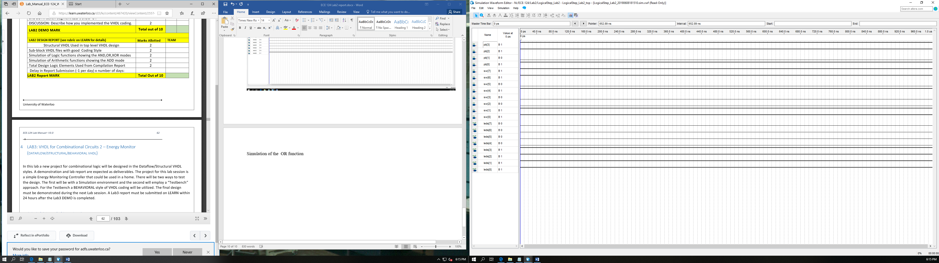

Simulation of the XOR function

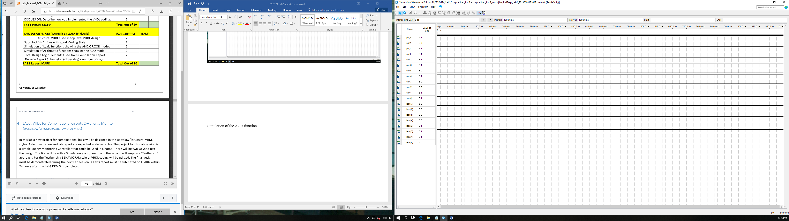

Simulation of the ADD function